Module 2 — Opportunity Cost in Farming
“If I had made a different decision, what is the best I could have got?”

1. Learning Objectives
- Understand the concept of Opportunity Cost in simple language.
- Learn how to work out opportunity cost from the records of your own farming costs.
- Understand how to use opportunity cost to make better-informed decisions about farming.

2. Introduction
Every decision of a farmer — which crop to grow, whether to work on his own farm or do labour elsewhere, whether to sell produce today or store it — carries a hidden price: the next best option he gave up. This hidden price is called opportunity cost.
Most farmers never work out this opportunity cost, because for that one must first know the cost of one’s own farming. In Module 1 we saw why the account of production cost is important — using this same account, we will now learn how to work out opportunity cost.

2.1 What is opportunity cost?
Opportunity cost is — the benefit that would have been obtained had the second best option been chosen instead of the option selected. Behind every farmer’s decision there is more than one option — e.g. flower farming or vegetables, organic or traditional farming, storing onions or selling right now, soybean or cotton.
Opportunity cost does not tell the farmer what to do — it tells him what he is actually losing in what he is already doing. And the only way to see this clearly is to keep one’s figures safe.
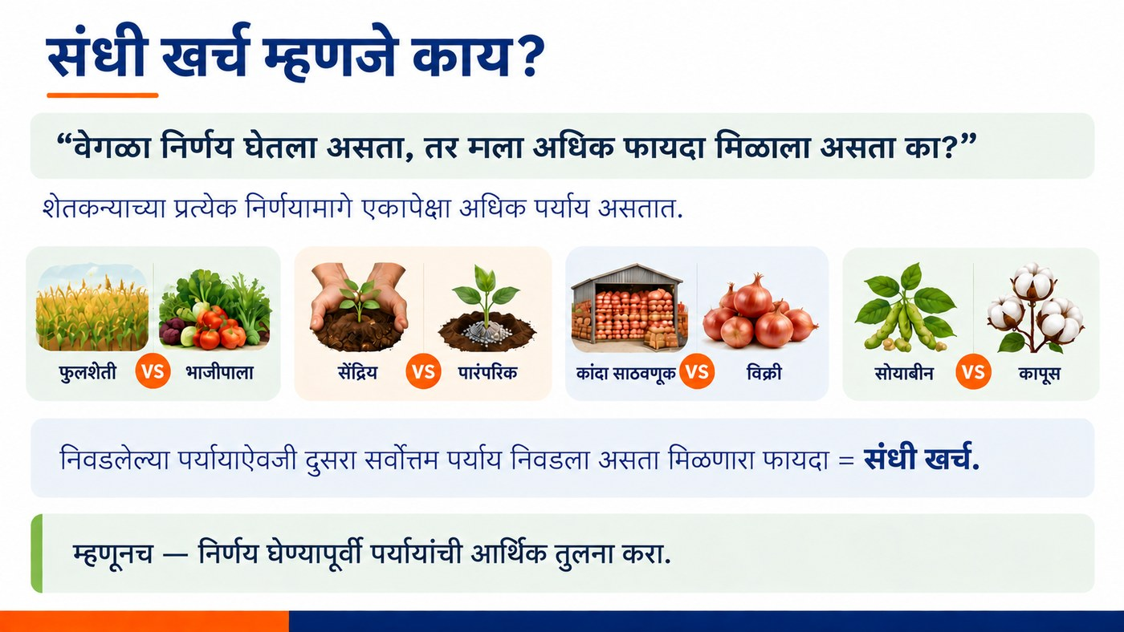
Figure 2.1 — What is opportunity cost? (Some typical choices in farming)

2.2 How to calculate opportunity cost?
Let us look at a real example of a soybean-growing farmer from Ahilyanagar district in Maharashtra. In the last kharif season he spent a total of ₹26,800 on one acre of soybean and earned an income of ₹30,000 — that is, a net profit of ₹3,200 per acre, and that too over a season of 90 days (3 months).
Now let us consider — if, instead of growing soybean on his own farm, this farmer had worked as a hired labourer for those same 90 days (for which he himself pays others ₹350 per day), he would have earned: ₹350 × 90 days = ₹31,500.
Table 2.1 — The real comparison (one season, one acre)
Route | How much earned (₹)
Growing soybean on own farm (net profit) | 3,200
Labour (₹31,500) + leasing out land (₹5,000) | 33,500

Besides this, this farmer also has one acre of land. Had he leased out (rented out) that land for this same season, he could have got at least ₹5,000. So the full opportunity cost is: ₹28,300 + ₹5,000 = ₹33,500.
That is, by doing labour (₹31,500) and leasing out the land (₹5,000), he could have got a total of ₹33,500 — which is ten times more than the actual net profit from soybean (₹3,200).
Formula for calculating opportunity cost
Opportunity cost = what could have been earned elsewhere − what was actually earned
In this example: ₹31,500 − ₹3,200 = ₹28,300
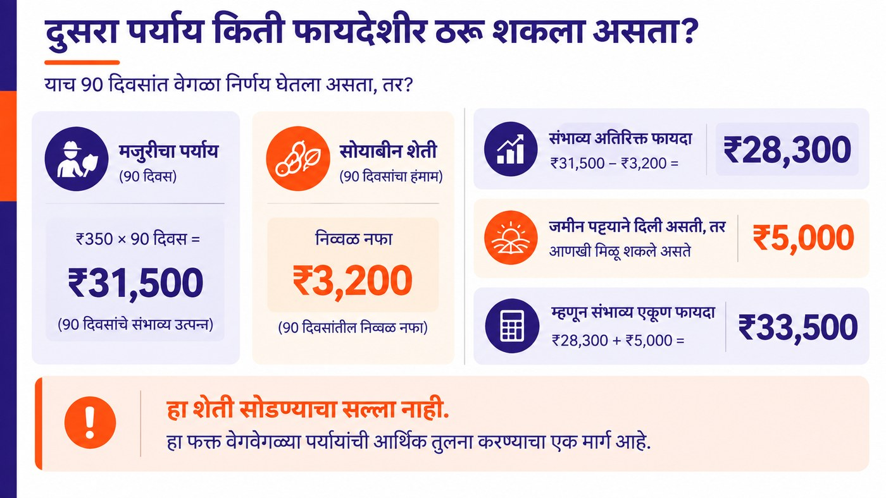
Figure 2.2 — Calculation of how profitable the other option could have been

2.3 Using opportunity cost for sound decisions
Opportunity cost is useful not only for “whether to farm or not” but also for smaller decisions — e.g. whether to sell produce today or store it and sell later. Let us look at an example: a farmer has 100 quintals of onion. If sold today (27 October) the price is ₹1,325/quintal — that is, he would get ₹1,32,500.
If he stores this same onion for 4 months (until 27 February), about 27.9% of the onion may spoil in storage (72.1 quintals remain saleable), the new price may be ₹1,000/quintal, and storage + handling costs come to ₹658/quintal. After working all this out, the expected net income is only ₹6,300.
That is, ₹1,32,500 if sold today versus only ₹6,300 if stored and sold — the difference between the two is the opportunity cost: ₹1,26,200. This example shows that one should not decide merely by looking at the difference in prices; the loss in storage, the cost and the uncertainty of prices should also be considered.
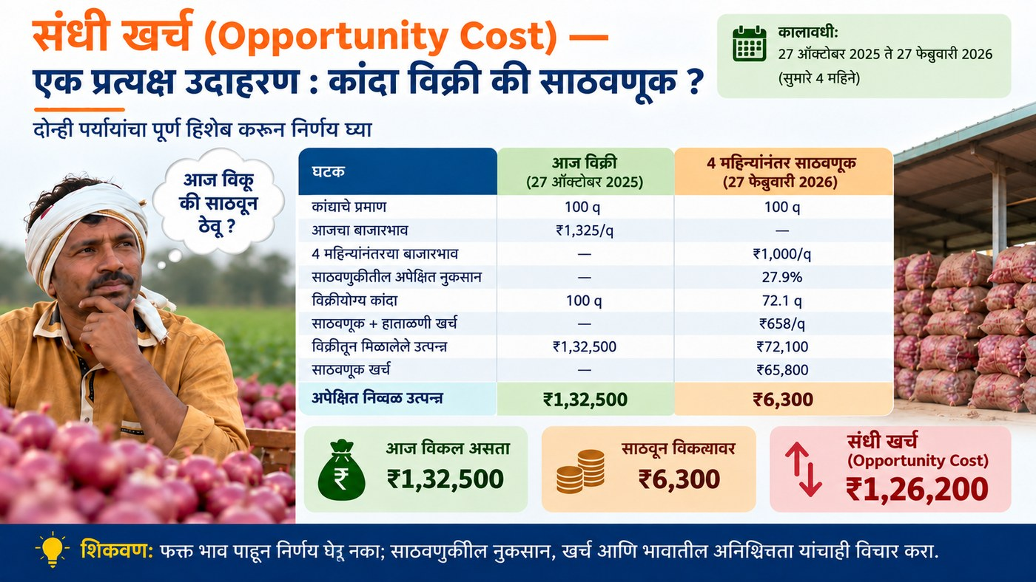
Figure 2.3 — Storing onions or selling right now? A real example
The real lesson is this — once a farmer knows his true opportunity cost, he can make decisions thoughtfully: whether he continues the same crop next season, shifts to a more profitable crop according to market demand, or looks for a different source of income. Without working out the production cost of farming, none of these decisions can be made on the basis of true information — one has to decide only by guesswork.
⚠ Important caution
This calculation is not advice to quit farming. It does not suggest that every farmer should leave farming and do daily-wage labour. If every farmer thought like that, there would be no labourers left to work on the farms — and the country’s economy would also suffer, which could lead to a shortage of foodgrain.

Key Concepts
- Opportunity Cost: the benefit obtainable from the next best alternative that was given up.
- Alternative income: the potential income obtainable from other sources such as labour and land rent.
- Storage risk: the loss, cost and price uncertainty that arise from storing produce.

Key Takeaways
- Opportunity cost = what could have been earned elsewhere − what was actually earned.
- Without knowing the cost of your own farming, it is not possible to work out opportunity cost.
- Opportunity cost is not advice to quit farming — it is only a tool for clearly comparing decisions.
- Opportunity cost should be considered even in decisions such as crop choice and timing of sale.

Review Questions
- Explain opportunity cost in your own words, with an example.
- How would you work out the opportunity cost of a crop, taking labour and land rent into account?
- What lesson do we learn from the onion storage example?

Module Summary
Opportunity cost is the benefit obtainable from the best alternative given up because of a decision. Without recording the cost and profit of your own farming, this opportunity cost cannot be worked out. From the comparison of soybean farming with labour, and from the onion storage example, we saw that considering opportunity cost helps a farmer make better-informed and more profitable decisions — but this calculation is not for quitting farming; it is for making sound decisions.

